**EPSA TEAM - CAR N°81**

**REAL CASE**

**ENGINE AND DRIVETRAIN**

Objective: 20% cost reduction – consequences on performance

Assemblies concerned with cost reduction:

|  |  |  |  |  |
| --- | --- | --- | --- | --- |
| Engine  (EN A0100) | Exhaust  (EN A0200) | Throttle body and air intake  (EN A300-0400) | Fuel system  (EN A500-0600) | Transmission  (EN A0900-1000-1100) |
|  |  |  |  |  |

|  |  |
| --- | --- |
| Initial cost of Engine and Drivetrain | $ 4205.19 |
| Final cost of Engine and Drivetrain | $ 3371.67 |
| **Reduction percentage** | **19.9 %** |

The 20% cost reduction target is almost achieved, with a modification of:

* the flat sump (manufacturing modification),
* the exhaust (simplification)
* the fuel system (modification of the fuel tank and the fuel system)
* the throttle body (simplification) and the air intake (simplification, one part instead of three)
* the differential internals (modification), the constant velocity joints (modification), the tripod housing (manufacturing modification) and the chain set (manufacturing modification)

These modifications cause a loss of performance of the car: power and torque are decreased, the fuel used must be as clean as possible, plenum is more difficult to manufacture and transmission performance is reduced. However, some parts are lighter.

It will reduce the performance of the car but in a reasonnable way, not leading in a massive decrease of global performances.

**ENGINE**

1. Flat sump manufacturing modification

|  |  |  |  |  |
| --- | --- | --- | --- | --- |
| Initial Solution | Final Solution | Initial Cost (part) | Final Cost (part) | Saving (part) |
| Flat sump : 4 parts made by laser cut, then bended, then welded together | Flat sump: A sand casting, a machining to rectify functional surfaces | $ 38.78 | $ 17.02 | Process: $ 21.76 |
| TOTAL |  |  |  | **$ 21.76** |

**EXHAUST**

1. Modification of the concept: 4-2-1 => 4-1. Coating removing.

|  |  |  |  |  |
| --- | --- | --- | --- | --- |
| Initial Solution | Final Solution | Initial Cost (assembly) | Final Cost (assembly) | Saving (assembly) |
| 2 Primary Collectors (+ tubing), 1 secondary collector. | No primary and secondary collectors. Other parts are simplified (less raw material, less welds, etc.). No coating. | $ 361.43 | $ 119.88 | Parts: $ 159.28  Materials: $ 5  Process: $ 77.27 |
| TOTAL |  |  |  | **$ 241.55** |

**THROTTLE BODY AND AIR INTAKE**

1. Throttle body simplification

2. Air intake modification

|  |  |  |  |  |
| --- | --- | --- | --- | --- |
| Initial Solution | Final Solution | Initial Cost (assembly) | Final Cost (assembly) | Saving (assembly) |
| Throttle body: 9 different parts, air filter | Throttle body: 3 different parts, smaller air filter | $ 170.24 | $ 84.97 | Parts: $ 33.27  Materials: $ 48.00  Process: $ 3.32  Fasteners: $ 0.68 |
| Air intake: Plenum in two parts + plenum plate between them | Air intake: Plenum in one part | $ 141.32 | $ 99.81 | Parts: $ 3.68  Materials: $ 0.10  Process: $ 36.13  Fasteners: $ 1.60 |
| TOTAL |  |  |  | **$ 126.78** |

**FUEL SYSTEM**

1. Fuel tank modification

2. Fuel system simplification

|  |  |  |  |  |
| --- | --- | --- | --- | --- |
| Initial Solution | Final Solution | Initial Cost (assembly) | Final Cost (assembly) | Saving (assembly) |
| Fuel tank: 4 aluminum parts, bended and welded together | Fuel tank: 2 plastic parts, made by injection, screwed | $ 199.49 | $ 117.32 | Parts: $ 82.17 |
| Fuel system: A fuel filter | Fuel system: No fuel filter | $ 342.71 | $ 328.71 | Materials: $ 14.00 |
| TOTAL |  |  |  | **$ 96.17** |

**TRANSMISSION**

1. Differential internals modification

2. Constant velocity joints modification and Tripod housing manufacturing modification

3. Chain set parts manufacturing modification

|  |  |  |  |  |
| --- | --- | --- | --- | --- |
| Initial Solution | Final Solution | Initial Cost (assembly) | Final Cost (assembly) | Saving (assembly) |
| Differential Internals: Limited Slip, Salisbury or Powerflow or Clutch Style | Differential Internals: Open gearset | $ 402.70 | $ 352.70 | Materials: $ 50 |
| Driveshaft: 4 Tripods, 4 tripod housings machined | Driveshaft: 2 Rzeppa fixed, 2 Tripods. No inboard tripod housings. Outboard tripod housing molded | $ 536.12 | $ 275.26 | Parts: $ 210.86  Materials: $ 50 |
| Chain set: Sprockets machined before a gear shaping | Chain set: Sprockets made by laser cut or machining, no gear shaping | $ 133.38 | $ 90.98 | Parts: $ 42.40 |
| TOTAL |  |  |  | **$ 353.26** |

**ASSEMBLY – ENGINE**

**Idea**

* Modifying the flat sump manufacturing.

**Effect on performance**

The performance of the part is the same, because of the machining process on functional surfaces.

Sand casting is not efficiency for a prototype, but for a mass production it is one of the more efficient ways.

**Cost table**

*The total amount of the flat sump is decreased by 56 %, from 38.78 $ to 17.02 $.*

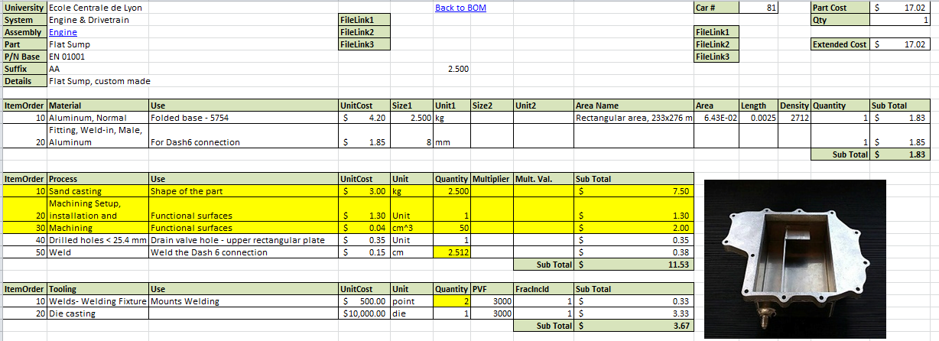

**ASSEMBLY – EXHAUST**

**Ideas**

* 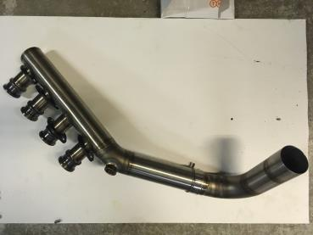Modifying the exhaust concept: from a 4-2-1 to a 4-1.
* Removing the coating process.

**Effect on performance**

**Mass**

* The exhaust is lighter, of about 1 kg.

**Manufacturing**

* There are fewer parts to manufacture.
* So, the manufacturing of the assembly is easier.

**Engine performance**

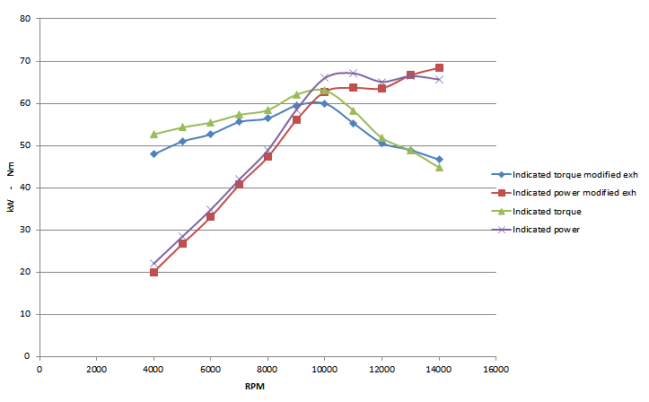

At 10000-12000 RPM, about 4 HP and 3 Nm are lost with the new exhaust.

**Cost tables**

*The total amount of the exhaust assembly is decreased by 67 %, from 361.43 $ to 119.88 $. This saving caused a loss of power of about 4 HP, a loss of torque of about 3 Nm, which is acceptable regarding the saving. Moreover, the system is about 1 kg lighter.*

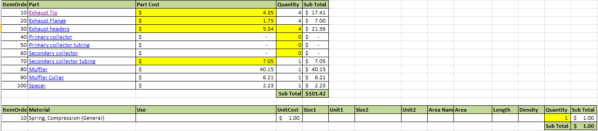

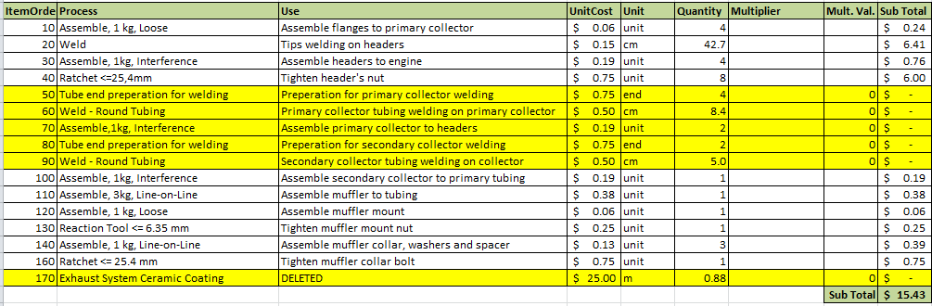

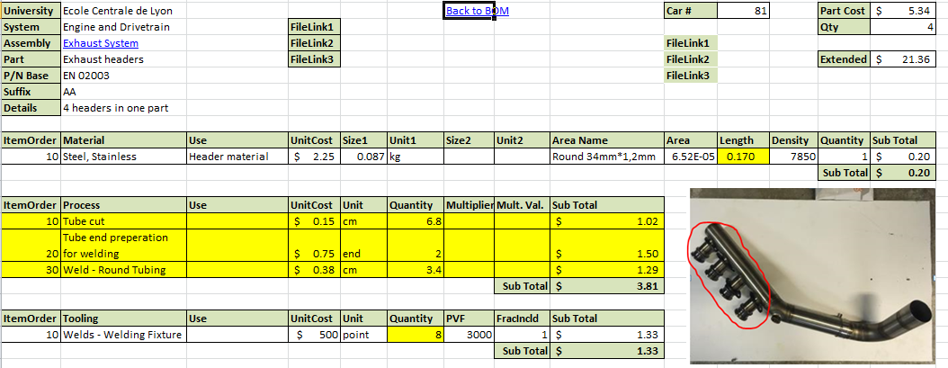

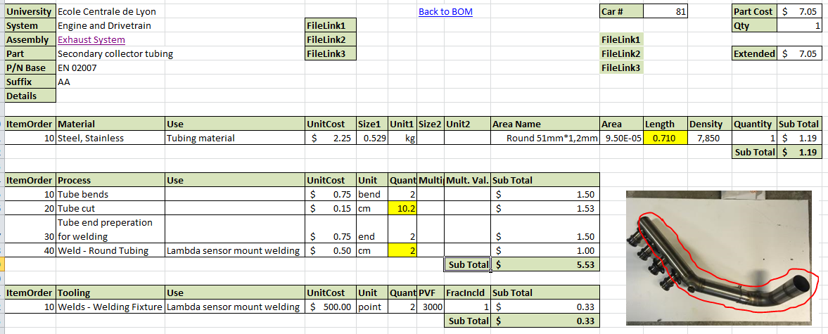

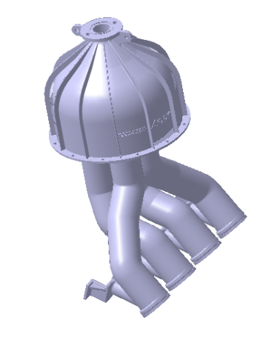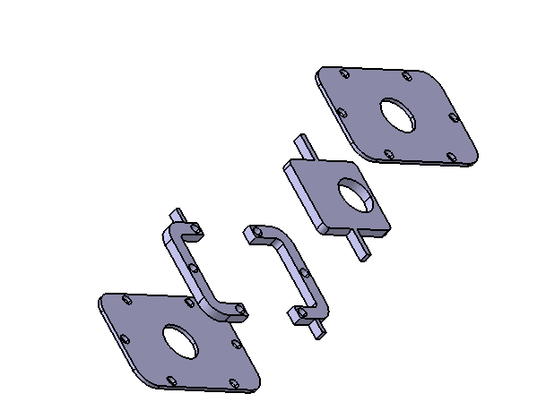**ASSEMBLIES – THROTTLE BODY AND AIR INTAKE**

**Ideas**

* Simplifying the full throttle body. Two bodies are riveting to a housing, which is carrying a mobile part, moved by a spring controlled by throttle pedal.
* Modifying the plenum, one bigger part instead of three smaller.

**Effect on performance**

**Mass**

* The throttle body is lighter of about 500 grams.
* The plenum plate is deleted, so the air intake is lighter of about 100 grams.

**Manufacturing**

* The throttle body is now very easy to manufacture and to assemble: laser cuts and some rivets are enough.
* The manufacturing of the plenum is more complicated because the part is bigger: a bigger 3D-printer is necessary. However, the assembly is easier, because two parts are deleted.

**Part quality**

* The new throttle body is maybe a bit less reliable than previous one.
* The one part air intake is less deformable, it could be harmful if backlashes occur. The bigger 3D-printer could be less accurate than the previous one.

**Cost tables**

*The total amount of these assemblies is decreased by 41 %, from 311.56 $ to 184.78 $. The performance of the throttle body is maybe less good, but the assembly is now lighter and easier to assembly.*

**THROTTLE BODY**

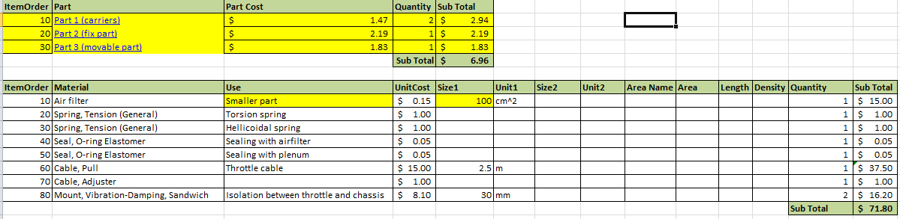

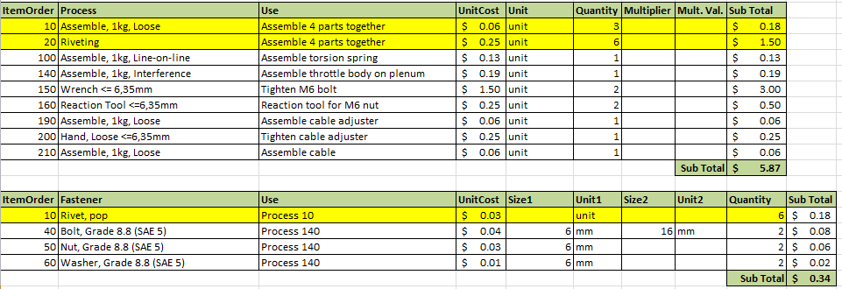

**AIR INTAKE**

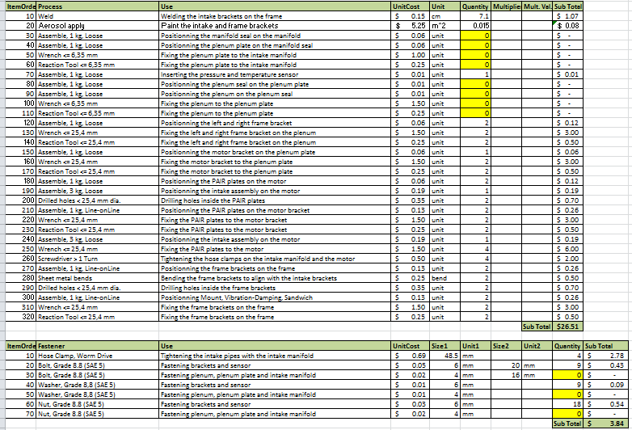

**ASSEMBLIES – FUEL SYSTEM**

**Ideas**

* Modifying the fuel tank manufacturing: 2 plastic parts made by injection and screwed, instead of 4 aluminum parts made by laser cut, bended and welded.
* Removing the fuel filter.

**Effect on performance**

**Mass**

* The fuel tank is lighter of about 700 grams.
* The removal of the fuel filter saves several grams.

**Manufacturing**

* Fuel tank manufacturing is cheaper, because plastic injection is more interesting for a mass-production part.

**Part quality**

* Plastic must be hermetic and must resist to fuel, so we use nylon. A sealing must be done, by the use of rubber here.
* Fuel impurities may damage the engine components.

**Cost table**

*The total amount of the fuel system is decreased by 18 %, from 542.20 $ to 446.03 $. This save is accompanied by a save of mass, even if the fuel used must be as good as possible.*

**FUEL TANK**

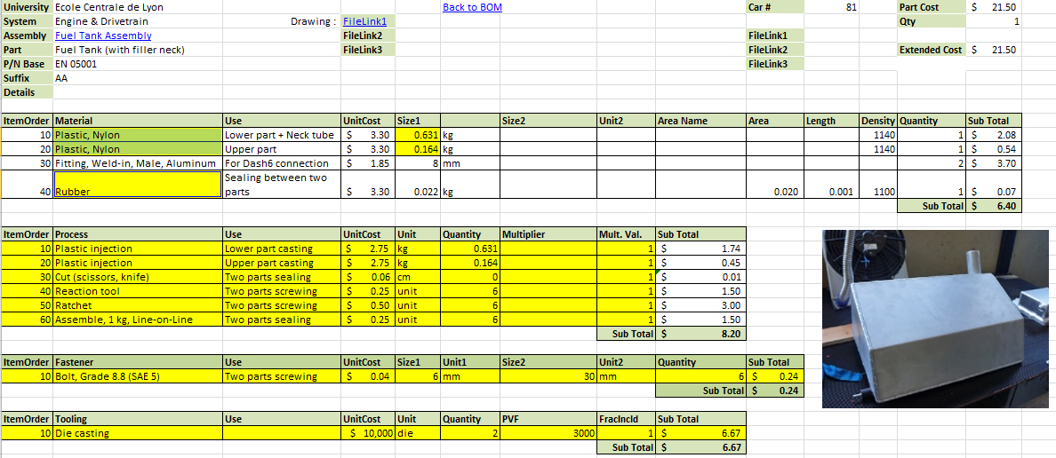**FUEL SYSTEM**

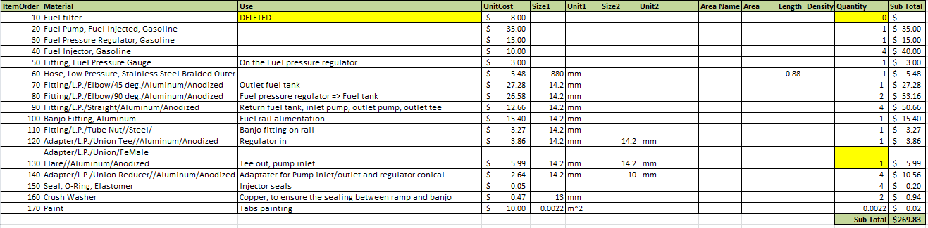

**ASSEMBLIES – TRANSMISSION**

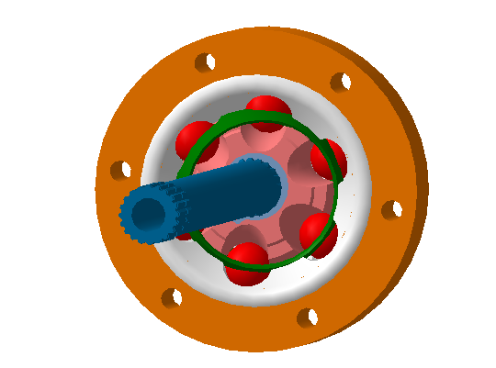**Ideas**

* 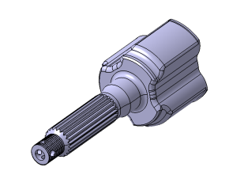Replacing the inboard tripods by Rzeppa joints. This modification causes the removing of the inboard tripod housings and a slight modification in the machining of the differential housing.
* Molding the outboard tripod housings, instead of machining.
* Replacing the limited slip differential by an open gearset.
* 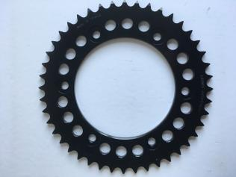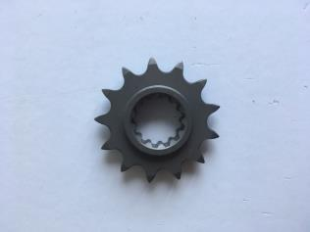Modifying the manufacturing processes of the sprockets, without gear shaping.

**Effect on performance**

**Mass**

* The masses of all the parts are globally identical.

**Manufacturing**

* Sand casting is not efficiency for a prototype, but for a mass production it is one of the more efficient ways.
* The manufacturing of the sprockets is easier, only machining and laser cuts are necessary.

**Part quality**

* The Rzeppa joints remove the axial translation of the shafts, but this translation is done by the tripods assembled with the wheels. The rotations are maintained.
* The outboard tripod housings are less durable. A heat treatment could be necessary.
* The open gearset differential could decrease the efficiency of the transmission, because if the inner wheel is not in contact with the track, the outer wheel (the only one in contact with the track) will not receive any torque, so the driver will can’t accelerate.
* The sprockets quality is the same, because the machining could be very accurate.

**Cost table**

*The total amount of the transmission is decreased by 33 %, from 1072.20 $ to 718.94 $. The global performance of the transmission is degraded.*

**DIFFERENTIAL**

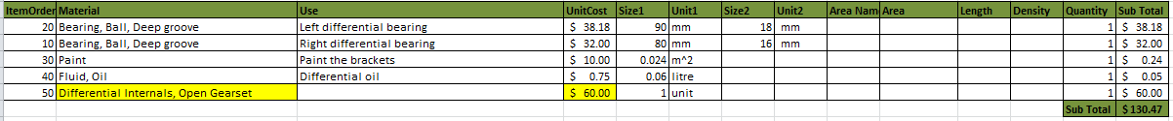

**OUTBOARD TRIPOD HOUSINGS**

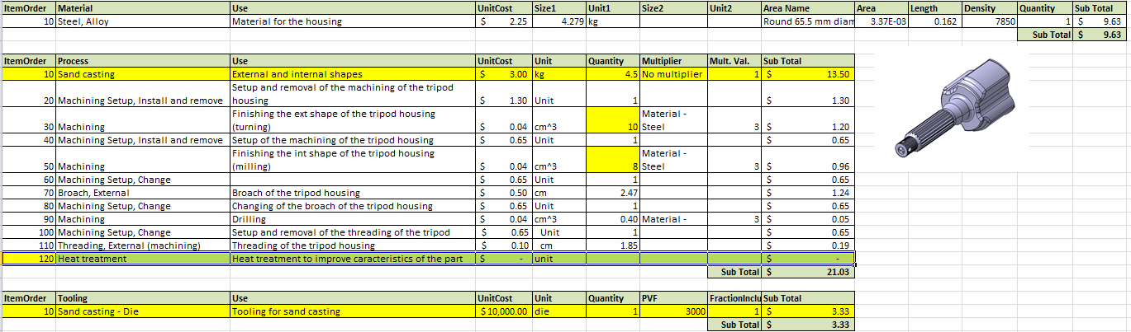

**RZEPPA JOINTS**

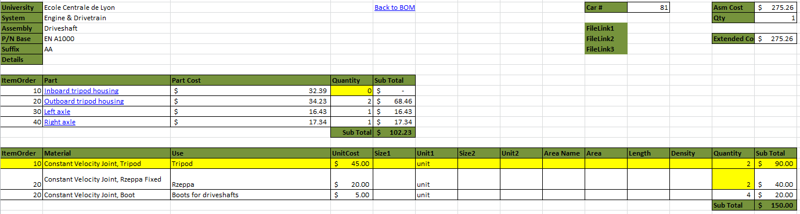

**SPROCKETS**

